Simulations with known amplitudes

K0 = 10 %% the number of users
P = 1 %% the detection window. In most cases, especially synchronous cases, it will be set to be 1
L = 64 %% the spreading gain.
LP = L*P
M = K0*4 %% the columns of the blind spreading matrix.
%% Theorectially, the large number, the better performance.
G = 3 %% the group size. the default is 1.
IsAsync = 0

R_S =

1.0000 -0.1250 0.0313 0.1563 0.0313 -0.1250 0.0625 -0.0313 -0.0313 -0.1563
-0.1250 1.0000 -0.0938 -0.0313 -0.1563 0.1250 0 0.1563 -0.0313 0.0313
0.0313 -0.0938 1.0000 -0.0625 0.0625 0.2813 0.2813 -0.1875 -0.0625 0.0625
0.1563 -0.0313 -0.0625 1.0000 -0.0625 -0.2813 -0.2188 0.1250 0.0625 0
0.0313 -0.1563 0.0625 -0.0625 1.0000 0.0313 -0.0313 0.1250 -0.0625 -0.1875
-0.1250 0.1250 0.2813 -0.2813 0.0313 1.0000 0.0625 0.0313 -0.2188 0.0313
0.0625 0 0.2813 -0.2188 -0.0313 0.0625 1.0000 -0.1563 -0.0313 0.0313
-0.0313 0.1563 -0.1875 0.1250 0.1250 0.0313 -0.1563 1.0000 -0.0625 0.0625
-0.0313 -0.0313 -0.0625 0.0625 -0.0625 -0.2188 -0.0313 -0.0625 1.0000 0.1250
-0.1563 0.0313 0.0625 0 -0.1875 0.0313 0.0313 0.0625 0.1250 1.0000

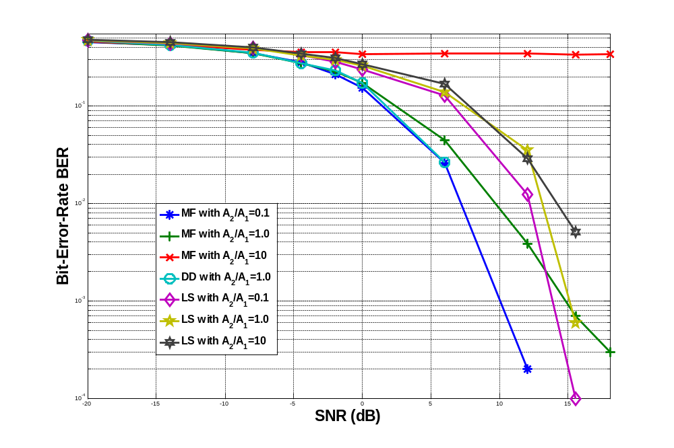

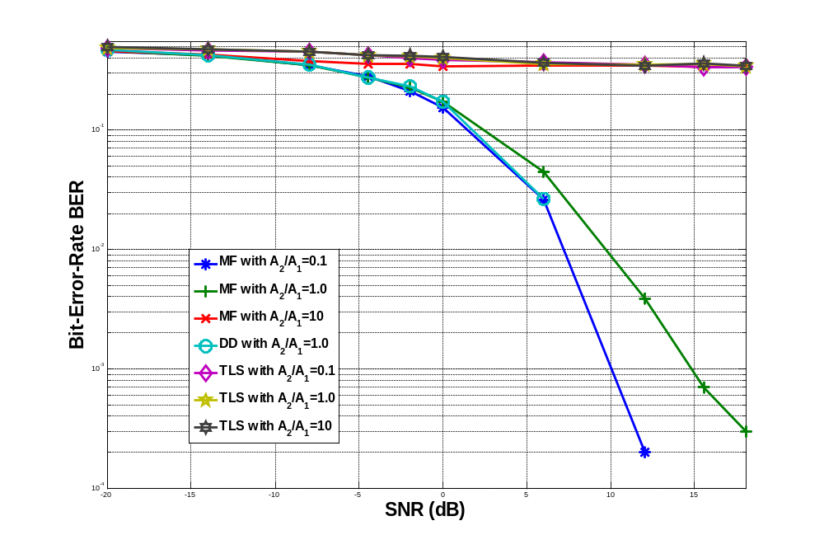
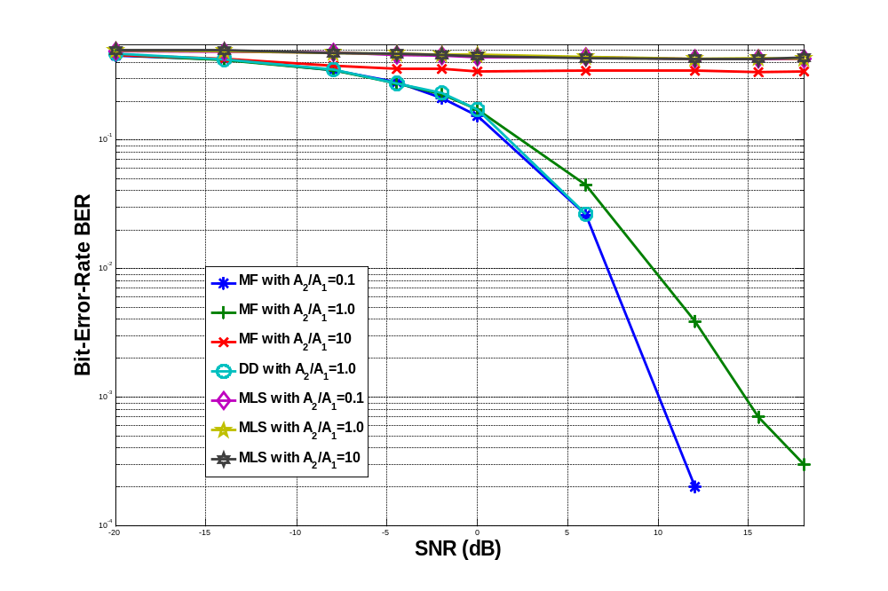

K0 = 2 %% the number of users
P = 1 %% the detection window. In most cases, especially synchronous cases, it will be set to be 1
L = 64 %% the spreading gain.
LP = L*P
M = K0*4 %% the columns of the blind spreading matrix.
%% Theorectially, the large number, the better performance.
G = 1 %% the group size. the default is 1.
IsAsync = 0

R_S =

1.0000 0.2188
0.2188 1.0000
